

**Project 1: Smart Weather (With Jira)**

***By: Akhil Tamgadge***

*OBJECTIVES*

* *To apply the concepts learned in the Agile Scrum Master course by analyzing a hypothetical organization.*

*INDUSTRY RELEVANCE*

* To facilitate all the communication and collaboration between leadership and team players to ensure a successful outcome.

*DESCRIPTION*

*GTM systems is a large IT company with offices all around the world. The company delivers software products and services to corporate clients. One of the reasons for its enduring success and consistent performance over the years is the ability to leverage technology and find innovative applications for it.*

*PROBLEM STATEMENT AND MOTIVATION*

*While GTM has no expertise in meteorology, it proposes to aggregate weather data from multiple providers and uses analytics to correlate it with meaningful conclusions for businesses. Example use cases could be generating forecasts based on local weather conditions around,*

* *Consumption of hot versus cold beverages depending on cold, sunny, or rainy weather.*
* *Number of visitors to a tourist site or an open-air entertainment event.*
* *Likelihood of seasonal illnesses such as flu in particular locations the main system will comprise a web portal and a set of “apps” available on the popular mobile operating systems. Apart from this, clients can ask for specific services or apps based on the insights that the analytics can generate.*

*EPICS AND USER STORIES*

*Epic 1: Data Aggregation and Integration*

*Epic 2: Analytics and Forecasting*

*Epic 3: Web Portal Development*

*Epic 4: Mobile App Development*

*Epic 5: Custom Services and App*

*Stage wise representation with Jira*

1. *Create 5 epics*
2. *Created Jira account and Scrum Project named*
3. *Backlog entered with Epic, stories and sub-tasks.*
4. *Tentative release plan, by assigning the stories to three sprints.*
5. *Complete sprint*

*1.EPICS*

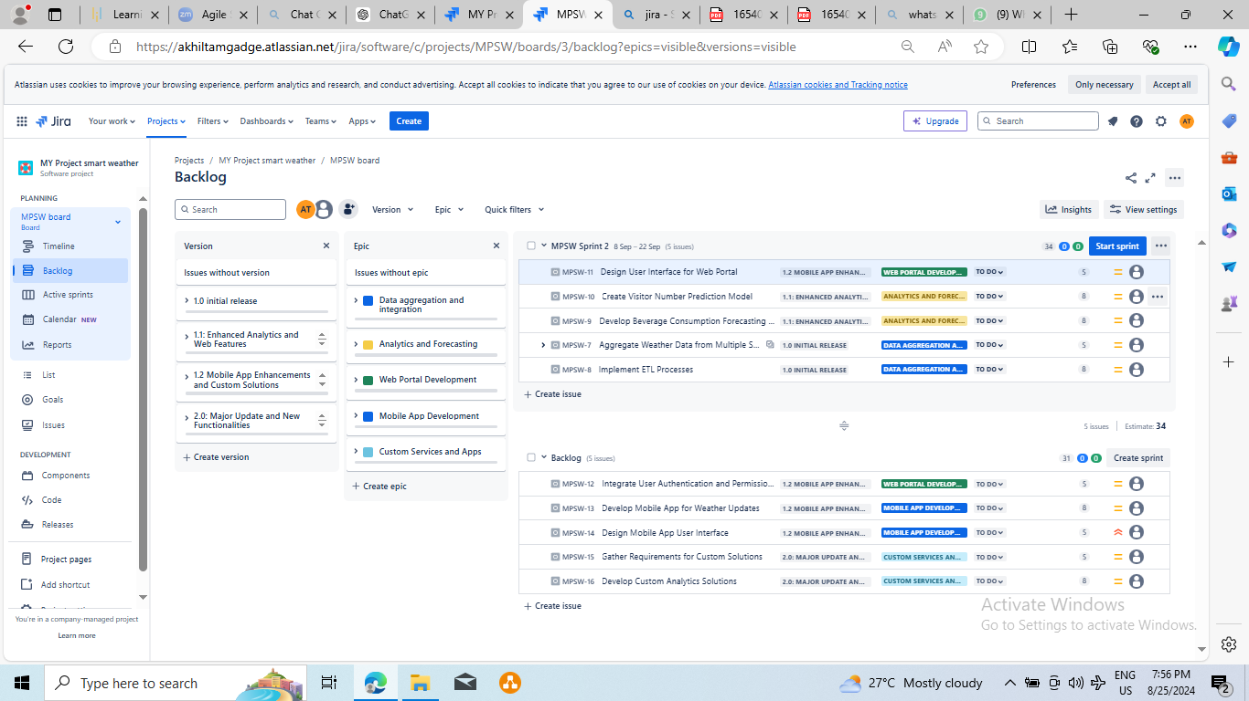

***2.BACKLOG***

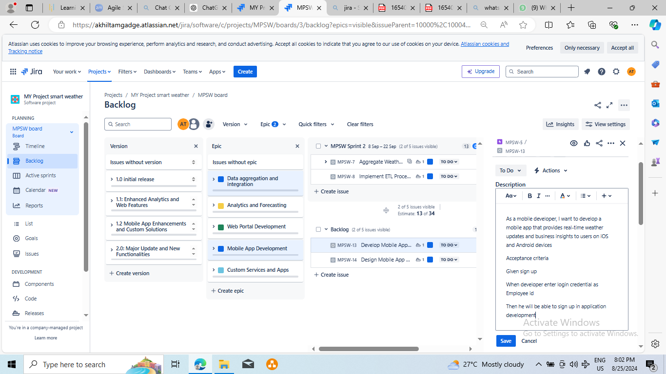

***3.Version***

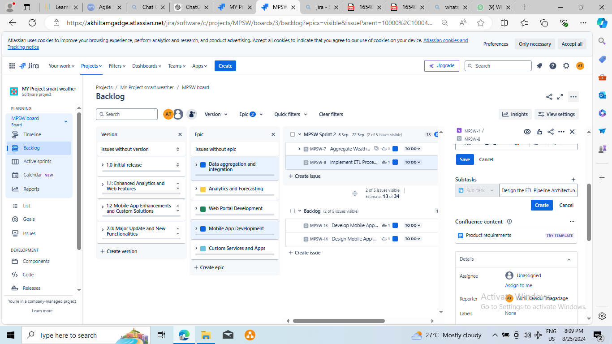

***4.****SUBTASKS*

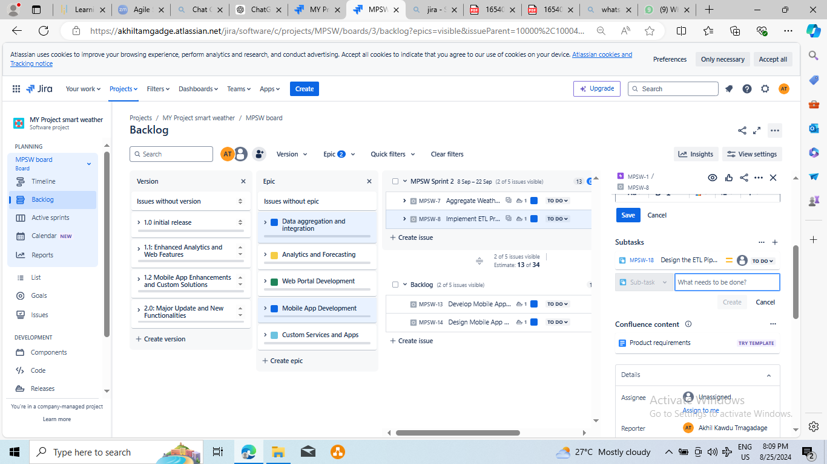

***5.SCRUM BOARD***

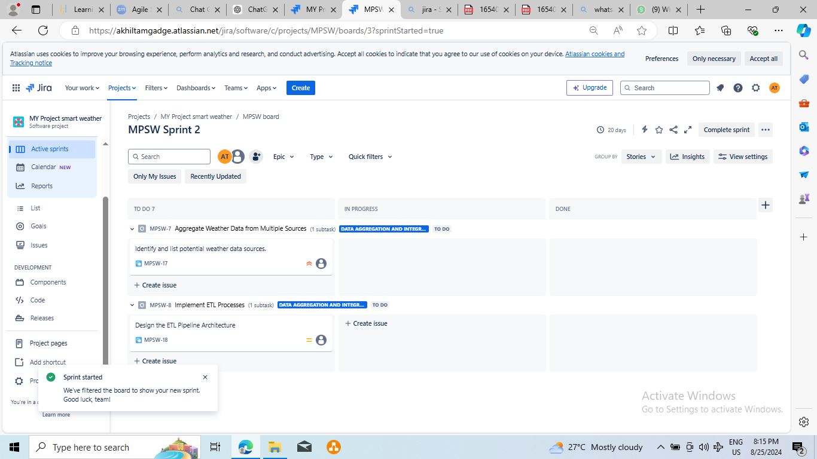

***6.SPRIT PHASE***

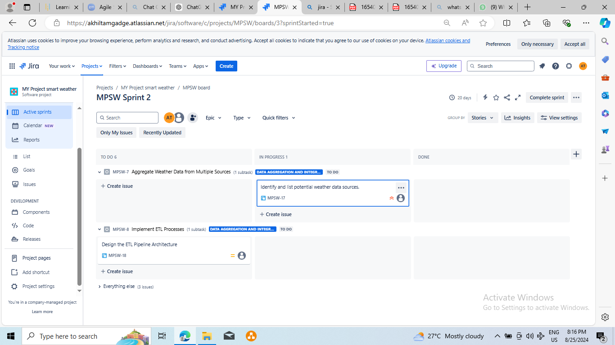

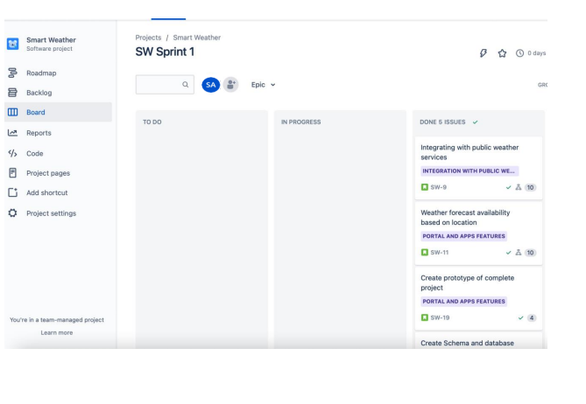

*PROJECT REFERENCE*

*Task 1 – Lesson 2,3,4*

*Task 2 – Lesson 4 &5*

*Task 3 – Lesson 5*

*Task 4 – Lesson 4,5,6*

*Task 5 – Lesson 6 and 7*